How to do it...

We want our Postcontroller action to accept parameters according to some specified rules and give the 404 not found HTTP response for all parameters that do not match. In addition, post/index should have an alias URL archive.

Add the following config of the urlManager component to @app/config/web . php:

'components' => [

// ..

'urlManager' => [

'enablePrettyUrl' => true,

'rules' => [

'post/<alias:[-a-z]+>' => 'post/view',

'<type:(archive|posts)>' => 'post/index',

'<type:(archive|posts)>/<order:(DESC|ASC)>' => 'post/index', 'sayhello/<name>' => 'post/hello',

]

],

// ..

],

The following URLs will be successful:

• <http://yii-book.app/post/test>

• <http://yii-book.app/posts>

• <http://yii-book.app/archive>

• <http://yii-book.app/posts/ASC>

• <http://yii-book.app/sayhello>

The following URLs will fail:

• http: //yii-book.app/archive/test

• http: //yii-book.app/post/another_post

The following screenshot shows that the URL http: //yii-book. app/post/test has run successfully:

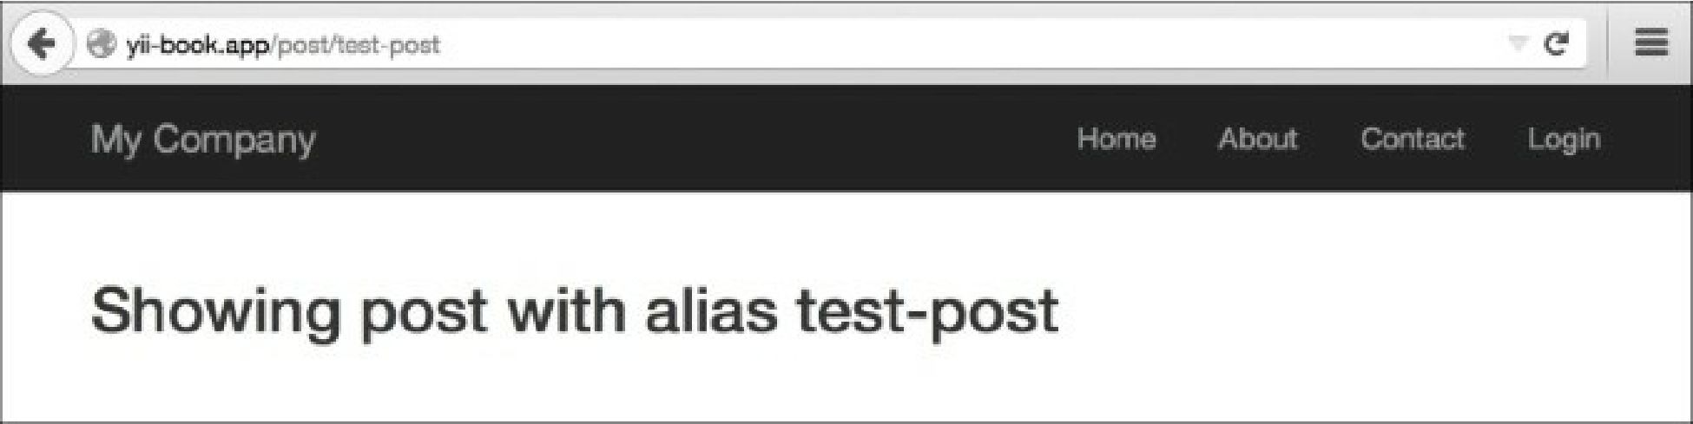

The following screenshot shows that the URL http: //yii-book. app/archive has run successfully too: